**Microsoft Project 2016: Tutorial 1**

**Getting Started**

NOTE – some of the material presented here is based on the “Learn MS Project 2013” tutorial developed by <https://www.tutorialspoint.com/ms_project/index.htm>. This content can be freely used within Schools, Colleges, Universities, Institutes and Companies as long as it is only for internal purpose and if there is appropriate references to tutorialspoint.com website. You are encouraged to use this site (and other resources) to supplement the material covered in this and subsequent tutorials.

**1. Introduction to MS Project 2016**

MS Project 2016 is (hopefully) available in all labs in the department. It can be started from the start menu (Start menu → All apps → Microsoft Office → Project 2016).

You should now see MS Project’s start screen. There are several options available here for creating a new project or opening an existing project:

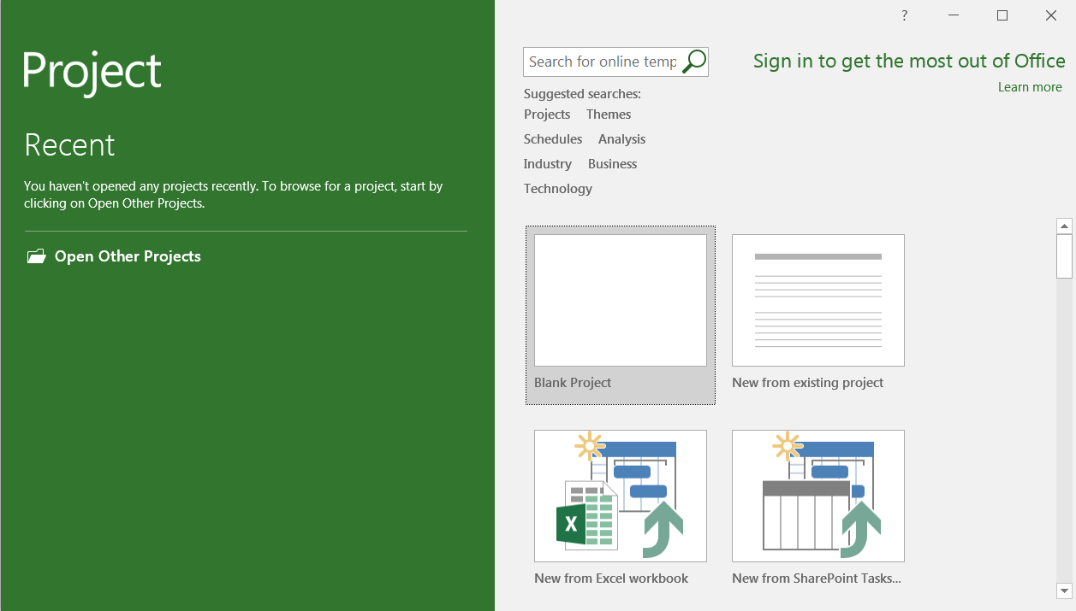

We want to start a new project, so click on the “Blank Project” tab. The following screen should appear:

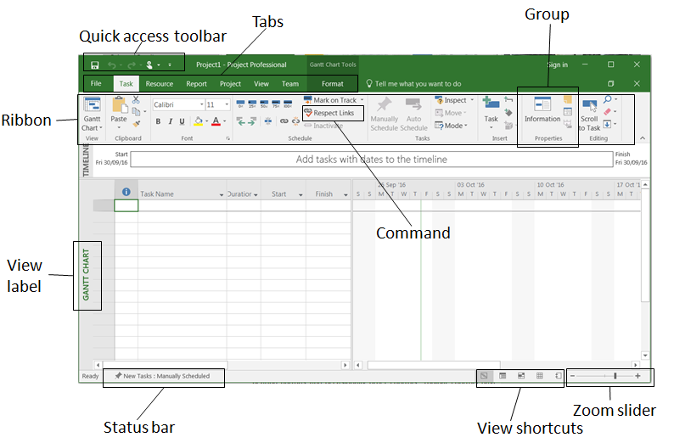

Important features of this interface include:

* **Quick Access Toolbar** − A customizable area where you can add the frequently used commands.
* **Tabs** – these replace the pull-down menus and toolbars with which you might be more familiar with. Tabs group high-level focus areas of Project together. There are eight tabs within Project 2016: File, Task, Resource, Report, Project, View, Team and Format.
* **Ribbon** - the main interface for accessing and using the features in Project.
* **Groups** - are collections of related commands. Each tab is divided into multiple groups.
* **Commands** − the specific features you use to perform actions in Project. Each tab contains several commands. If you point at a command you will see a description in a tooltip.
* **View Label** − appears along the left edge of the active view. The active view is the one you can see in the main window at a given point in time. Project includes lots of views like Gantt Chart view, Network Diagram view, Task Usage view, etc. The View label just tells you about the view you are using currently. Project can display a single view or multiple views in separate panes.
* **View Shortcuts** − This lets you switch between frequently used views in Project.
* **Zoom Slider** − Zooms the active view in or out.
* **Status bar** − Displays details like the scheduling mode of new tasks (manual or automatic) and details of filter applied to the active view.

**2. Creating a plan**

By default, Project sets a plan’s start date to the current date. This is shown as a thin green line in the chart portion of the Gantt Chart View:

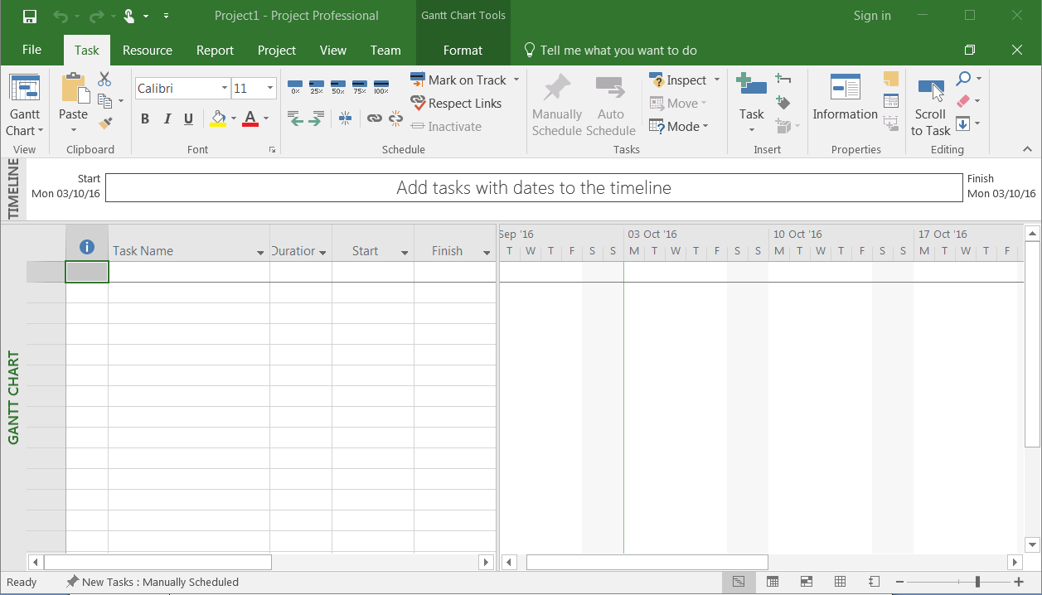

**2.1 Start date**

To begin, we’ll change the project start date and add some additional information.

Click the Project tab, and then from the Properties Group click on Project Information:

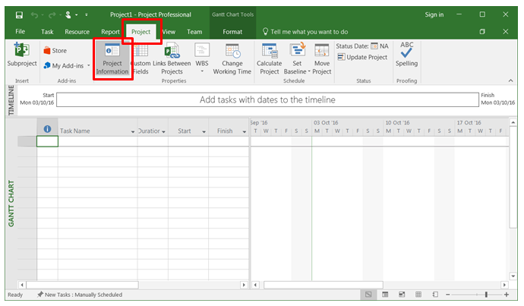

A dialog box should appear. In the start date type “31/10/2016”, or click the down arrow to select that date from a calendar.

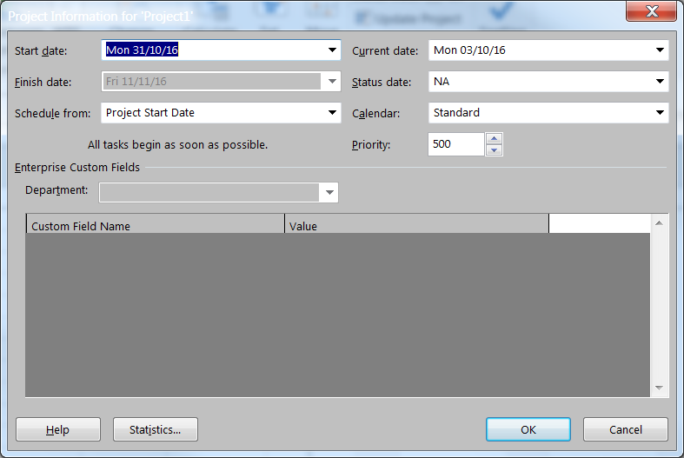

Click **OK** to accept the new start date.

**2.2 Calendar**

Return to the Project Information dialog box (Project tab -> Properties Group –> Project Information). Click the arrow on the Calendar drop down box. A list appears containing 3 base calendars:

24 Hour – a calendar with no non-working time

Night Shift – covers 11pm to 8am, Monday to Friday, with 1 hour breaks

Standard – Regular working hours, Monday to Friday, 8am to 5pm, with 1 hour breaks

Make sure that Standard is selected as your Project Calendar. Click **OK** to close the dialog box.

**2.3 Add an Exception to the Calendar**

It is possible to include exceptions in the Calendar. For example, a non-working day can be introduced, maybe to accommodate a special holiday or office event. Click Project tab -> Properties Group –> Change Working Time. The following dialog box should appear:

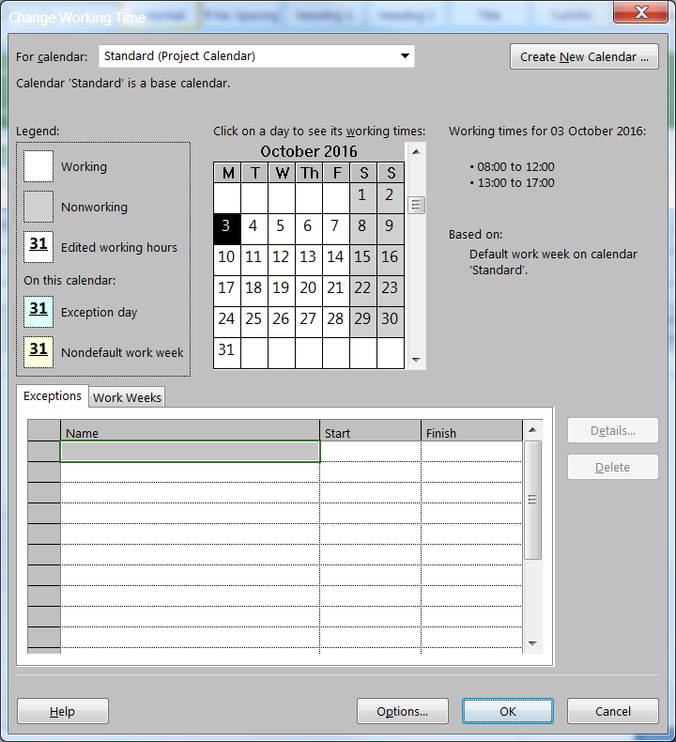

Under the Exceptions Tab click on the Name field and enter “Office Anniversary”. In the Start field enter “10/11/2016”. Enter the same date in the Finish field. This date is now scheduled as a non-working day for this project.

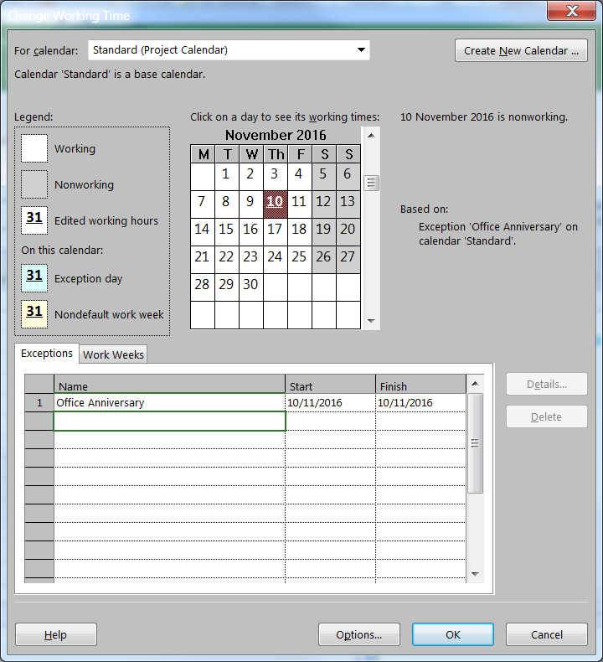

Click on OK. You might be able to make out that 10/11/2016 has been greyed out in the Gantt chart window (weekends are already greyed out by default) – meaning it is a non-work day.

**2.4 Build a Task List**

We assume here that a list of project Tasks has already been compiled, together with task duration and task dependency information. Consider the following list of project tasks:

|  |  |
| --- | --- |
| **Task name** | **Duration** |
| Design software | 5 days |
| Purchase hardware | 3 days |
| Implement software | 10 days |
| Test system | 3 days |
| Deploy system | 1 day |

Entering tasks is straight forward. In Gantt Chart View, just click a cell directly below the Task Name column, and simply enter the task name:

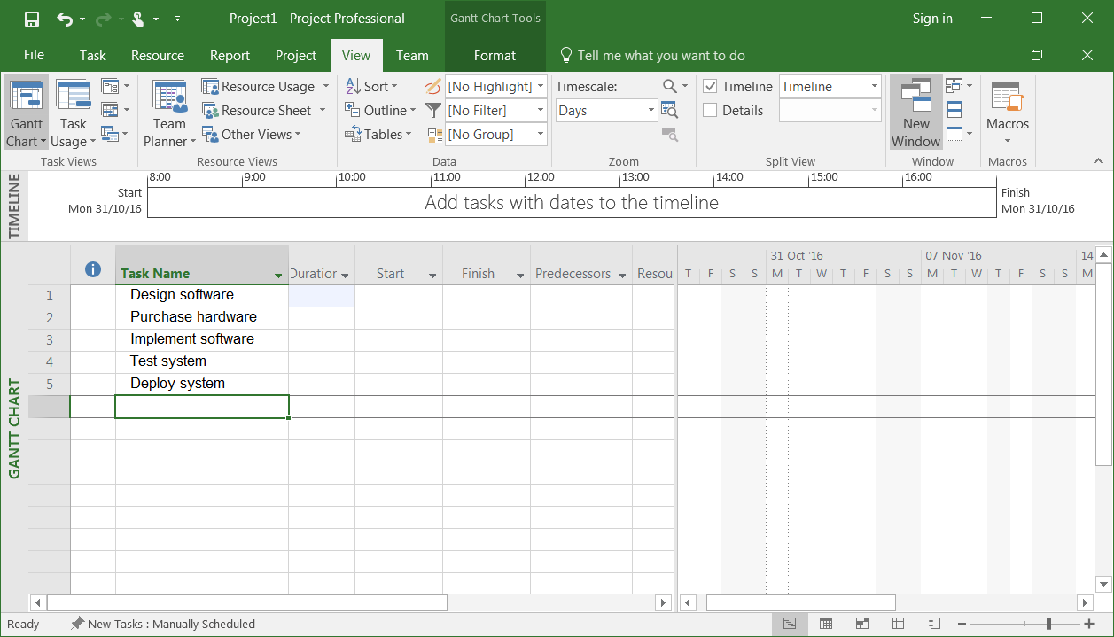

Task duration can be entered in various units of time (i.e. minutes, hours, days, weeks and months). By default, Project assumes Days as the default unit. The duration of each task can be added to Project via the Gantt chart view – simply select the appropriate cell in the Duration column. You override the default time unit in a couple of ways. First, you can enter the task duration unit as you type each task duration. So, for example, for Design software task, you would type “5 days” or “5d” in the duration cell:

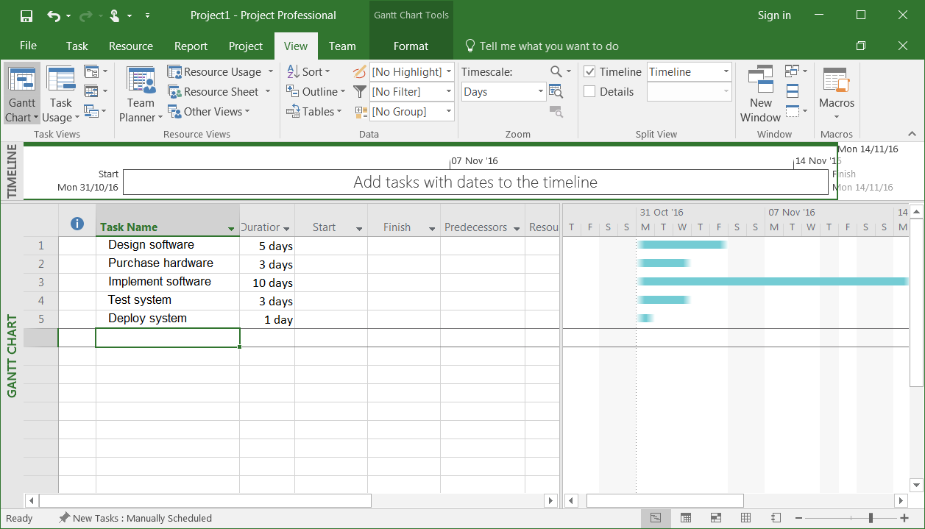

Notice that time bars appear in the right-hand pane. Until we tell MS Project otherwise, all the tasks will start on the project start date (31st October).

The default time unit for a project can be changed via the Project -> Properties -> Change Working Time -> Options dialog box:

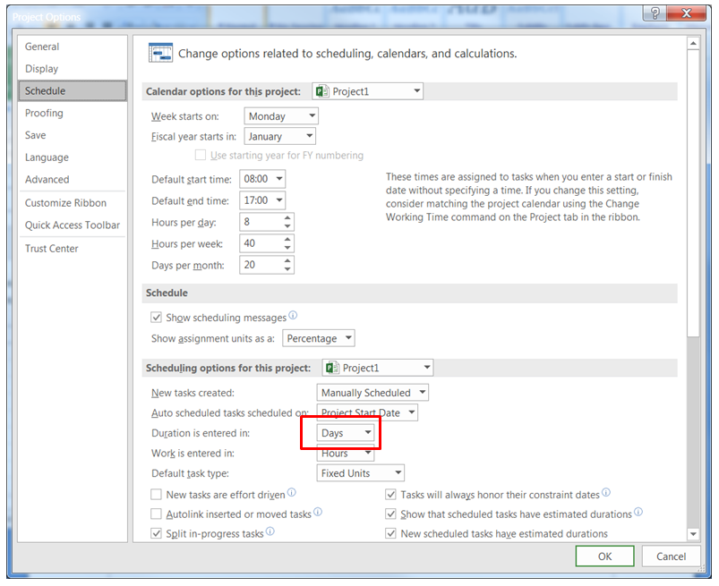

**2.5 Save the Project**

We will be using this project in future tutorials, so you need to save it. Select the File tab. The Backstage View window should open (you will see a similar Backstage window in other Office 2016 applications). Save the project (using Save or Save As), giving it the name “SimpleSoftwareProject”. Make sure to save it to a drive that you will have access to from other machines and other labs.

**3. Practice**

Create a new project. Set the project start date to 19th January 2017. Set the 24th and 25th January to be non-working days. Add the following tasks and their durations:

|  |  |
| --- | --- |
| **Task name** | **Duration** |
| Obtain planning permission | 8 weeks |
| Purchase building materials | 6 weeks |
| Purchase equipment | 3 weeks |
| Select and hire contractors | 2 weeks |
| Prepare site | 3 weeks |
| Build the new restaurant | 15 weeks |
| Install mains services | 5 weeks |
| Install equipment | 3 weeks |
| Decorate | 3 weeks |
| Purchase consumables | 2 weeks |
| Hire staff | 2 weeks |
| Train staff | 2 weeks |
| Open restaurant | 0 weeks |

This will give you a project (in Gantt Chart view) that looks like:

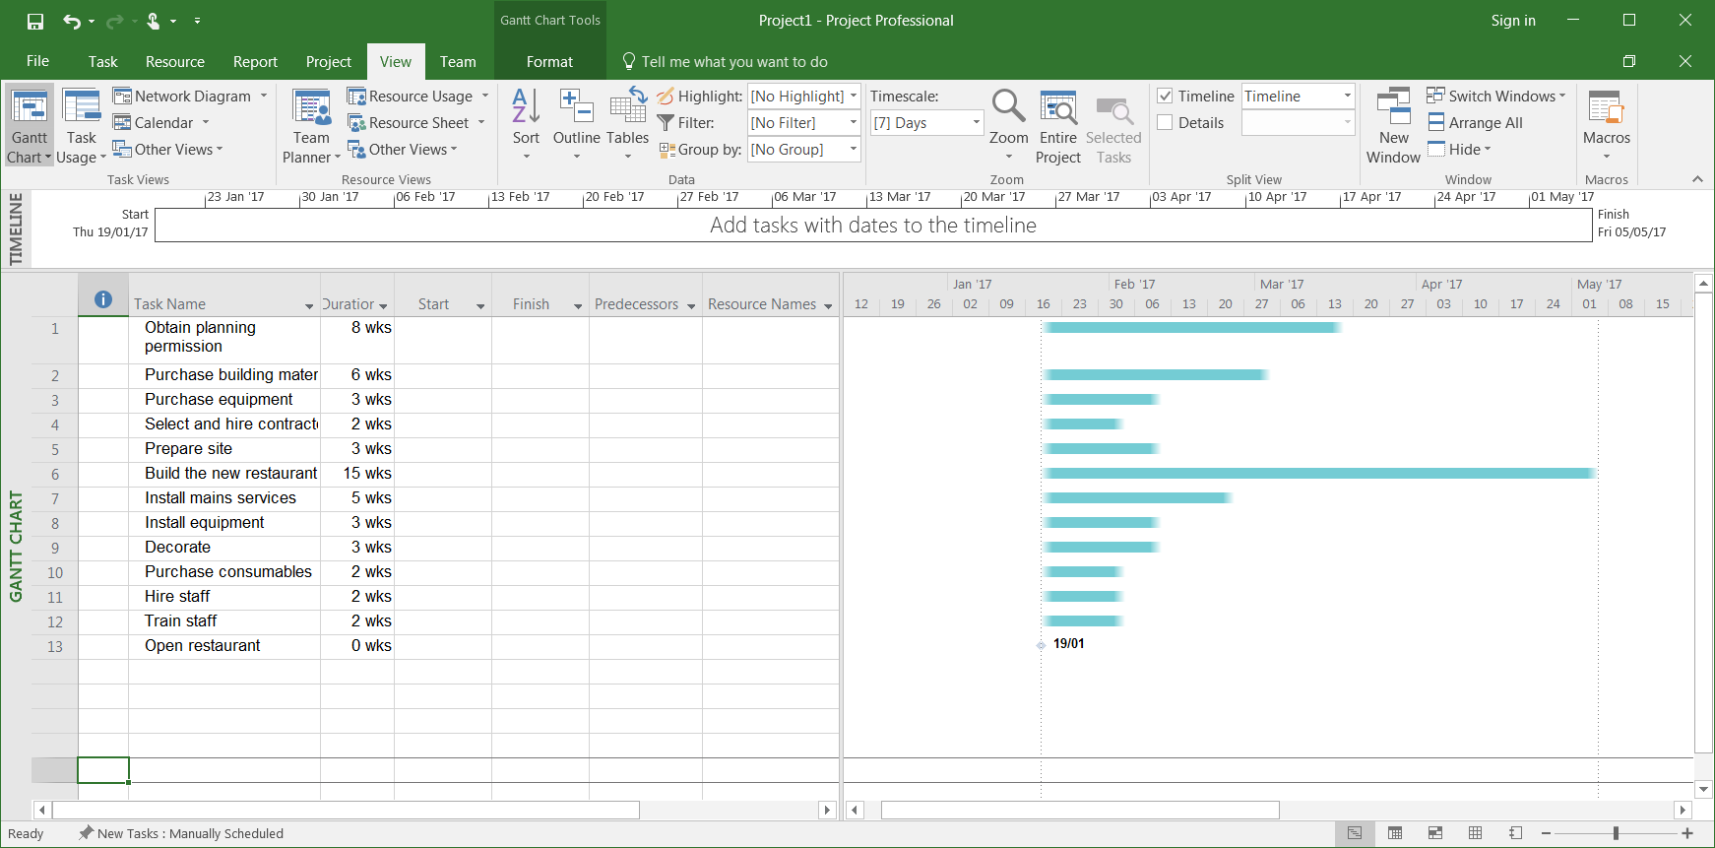

We’ll be using this project in future tutorials, so save it – give it the name “BuildRestaurant”.